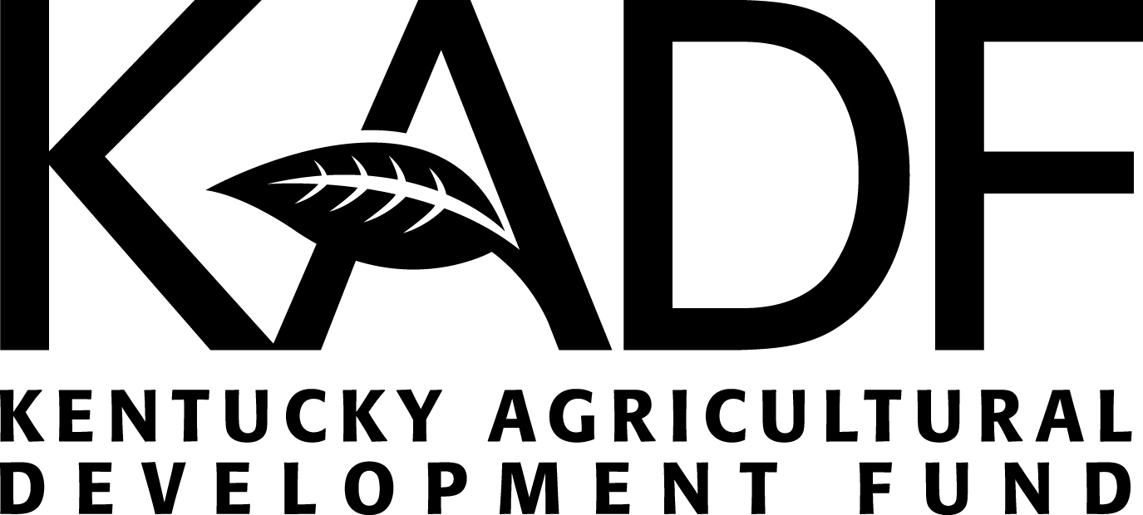
Checklist for 2023 CAIP Program Administration

 | Item | Date Completed
 | Complete Application for New Program or Amendment and Submit to County Council. County Council forwards Application, Prioritization Sheet and Conflict of Interest Form to KOAP.
Receive Letter of Acknowledgement from KOAP
- Letter will provide application number and KADB meeting date
Application #: __________________ Board Meeting Date: ________________
 | KADB Decision (KADF Programs Manager will communicate board decision via email)
 | Receive Legal Agreement or Amendment from KOAP
Return Legal Agreement or Amendment Signed by Authorized Representative
- Submit proof of bonding with legal agreement if not previously submitted
 | Receive Executed Legal Agreement from KOAP  - Date the KOAP Exec. Dir. signs the agreement is the execution and anniversary date | Execution Date:  _____________
 | Receive Funds
Advertising & Promotion
- Minimum 3 week period, beginning after executed agreement is received
- Advertisement/Promotion shall acknowledge that this program is sponsored in part by the Kentucky Agricultural Development Fund (KADF)*
- Send copy of advertising/promotion to KOAP, no later than with submission of 6-month reports
Date Begin: _____________________ Date End: _______________________
Application Period
- Minimum 15 business days, beginning after executed agreement is received
Date Begin: _____________________ Date End: _______________________
Score Universal CAIP Producer Applications
- Each application shall be scored by three or more individuals from the administrating entity
(See guidelines for additional requirements for scoring committee.)
Notify Producers in Writing of Approval, Waiting List, or No Fund Status
- Templates provided by KOAP
Set Deadline for Submission of Proof of Purchase and Producer Report & Certification
Deadline Date:____________________
 | Conduct Site Visits (minimum of 25% of approved applicants or 13 recipients, whichever is lesser; all capital construction projects shall be visited)
Reimburse Producer
- Educational component shall be attained by producer prior to reimbursement (completed in the last 6 months. See guidelines for details.)
- Producer Report & Certification form must be completed by producer and submitted to administrator prior to reimbursement
- No cash purchases may be reimbursed; beginning in 2020 proof of payment will be required
- Each check shall be signed by 2 members of the administrating entity
Submit 6-month Summary & Detail Reports⁺
Date due: ______________________ (6-months after the execution date)
Submit 12-month Summary & Detail Reports⁺ Date due: _________________
Note: The 12-month report is not a cumulative report; only covers the last 6-months of agreement
Submit Copies of Cancelled Checks to KOAP
(no later than 60 days after the final report or anniversary date, whichever comes first)
Submit Any Remaining Funds to KOAP
- Each check shall be signed by 2 members of the administrating entity
- Make check payable to: KY State Treasurer and mail to KOAP, 107 Corporate Dr., Frankfort, KY 40601
 | Receive Letter of Completion from KOAP
*The KADF logo can be downloaded at https://www.kyagr.com/agpolicy/Kentucky-Agricultural-Development-Fund-Administrators.html.
⁺Reporting forms can be downloaded at https://www.kyagr.com/agpolicy/Kentucky-Agricultural-Development-Fund-Report.html

